**SNOWFLAKE-2025**

**1.What is Snowflake?**

Snowflake is a cloud-based data warehousing platform that separates compute from storage, allowing users to scale their processing resources and data storage independently.

**2.What are the key features of Snowflake?**

Key features include auto-scaling, multi-cloud support, data sharing, and separation of compute and storage

**3.Explain Snowflake's architecture ?**

Snowflake's architecture consists of three layers: Database Storage, Compute (Virtual Warehouses), and Cloud Services

**4.What is Snowflake Time Travel ?**

Time Travel allows you to access historical data at any point within a defined period, enabling you to recover data that may have been accidentally deleted or modified

**5.How does Snowflake handle data sharing ?**

Snowflake allows secure data sharing without the need to copy or move data. It uses a unique approach where shared data is accessible in real-time

**6.What is a Virtual Warehouse in Snowflake?**

A Virtual Warehouse is a cluster of compute resources in Snowflake that performs data processing tasks. It can be scaled up or down based on the workload

**7.How do you optimize query performance in Snowflake?**

Query performance can be optimized by using clustering keys, partitioning data, and leveraging Snowflake's automatic query optimization features

**8.What is SnowPipe ?**

SnowPipe is a continuous data ingestion service in Snowflake that allows you to load data as soon as it becomes available

**9.Explain the concept of micro-partitions in Snowflake ?**

Micro-partitions are the smallest unit of data storage in Snowflake. They are automatically created and managed by Snowflake to optimize storage and query performance

**Snowflake Architecture :-**

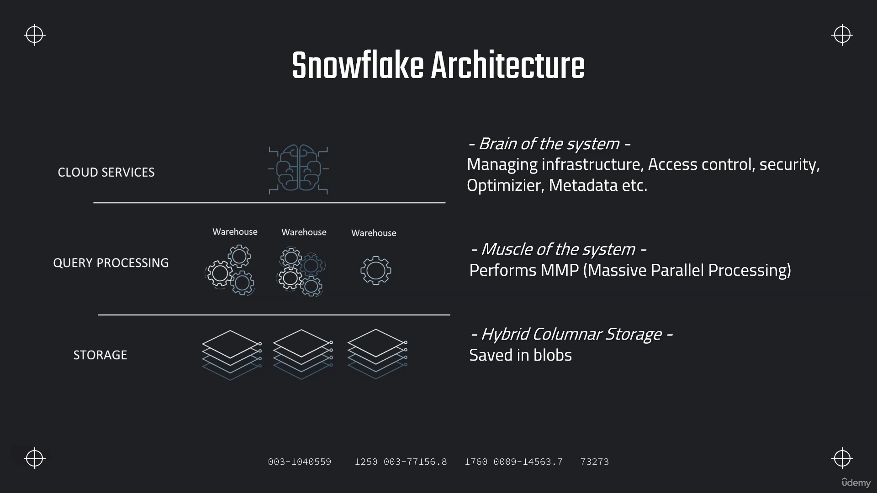

**Warehouse creation using SQL :**

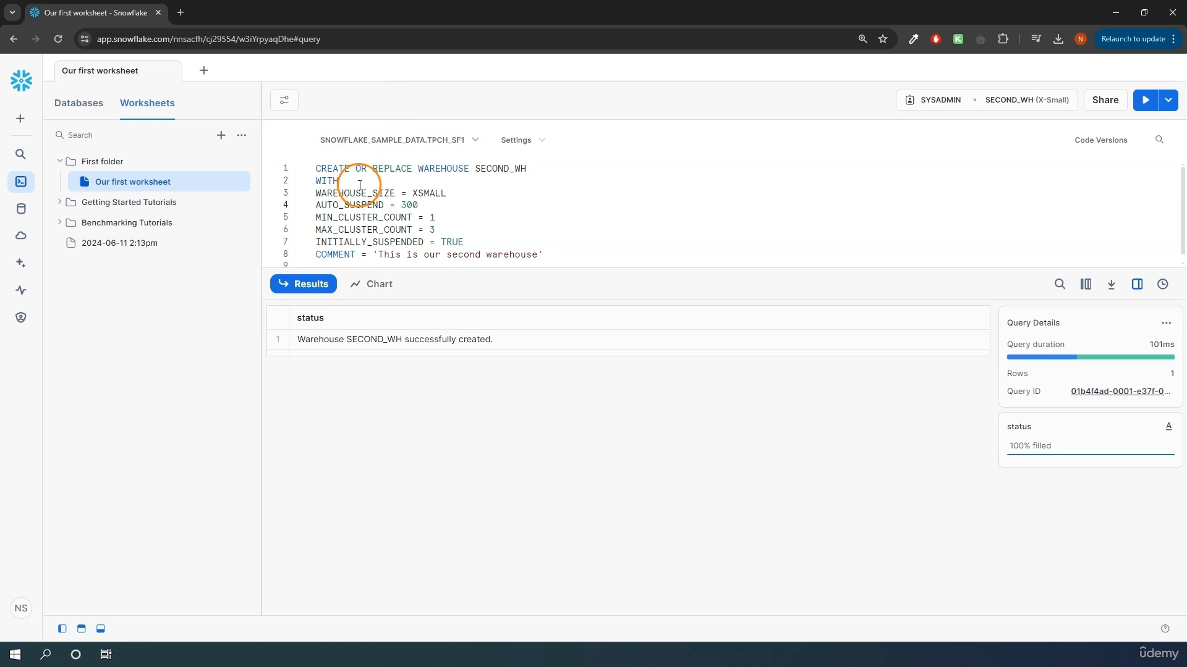

create or replace warehouse second_wh

with

warehouse_size =xsmall

auto_suspend=300

min_cluster_count=1

max_cluster_count=3

initially_suspended=true

comment='This is second warehouse'

**Alter Warehouse**

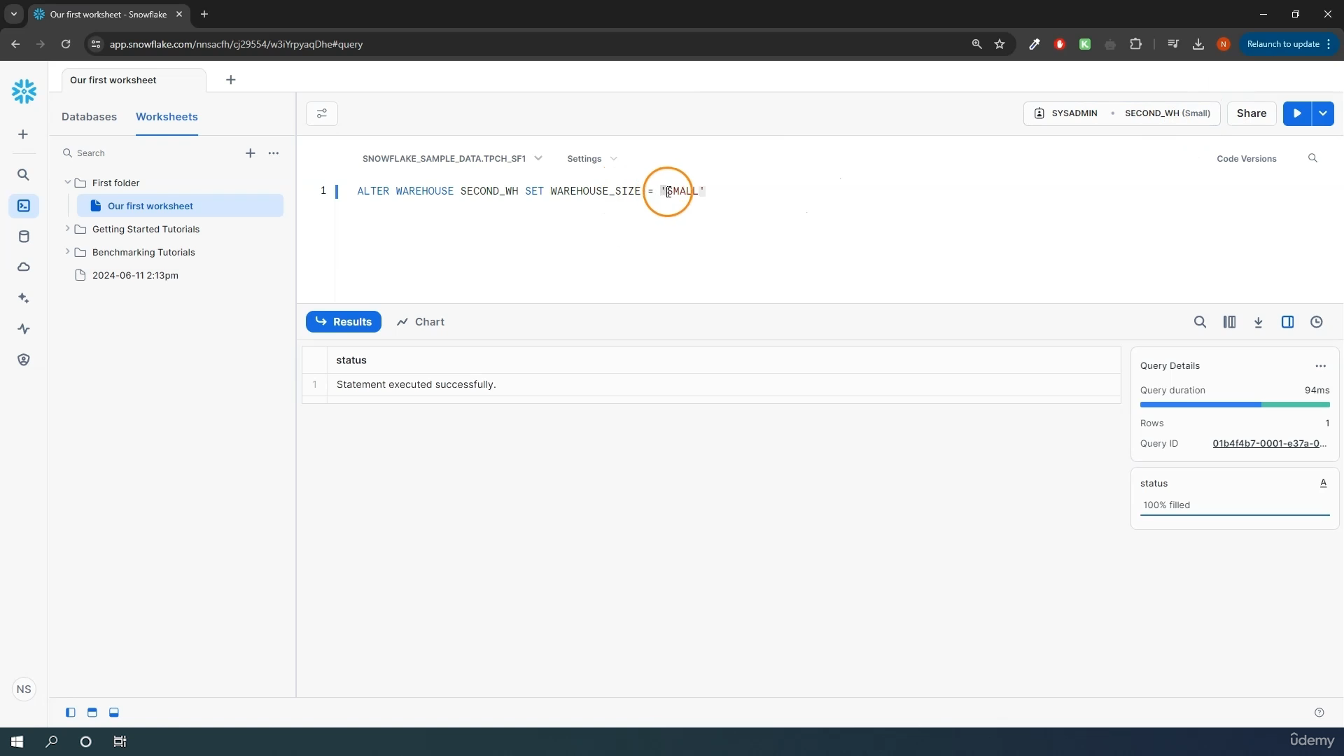

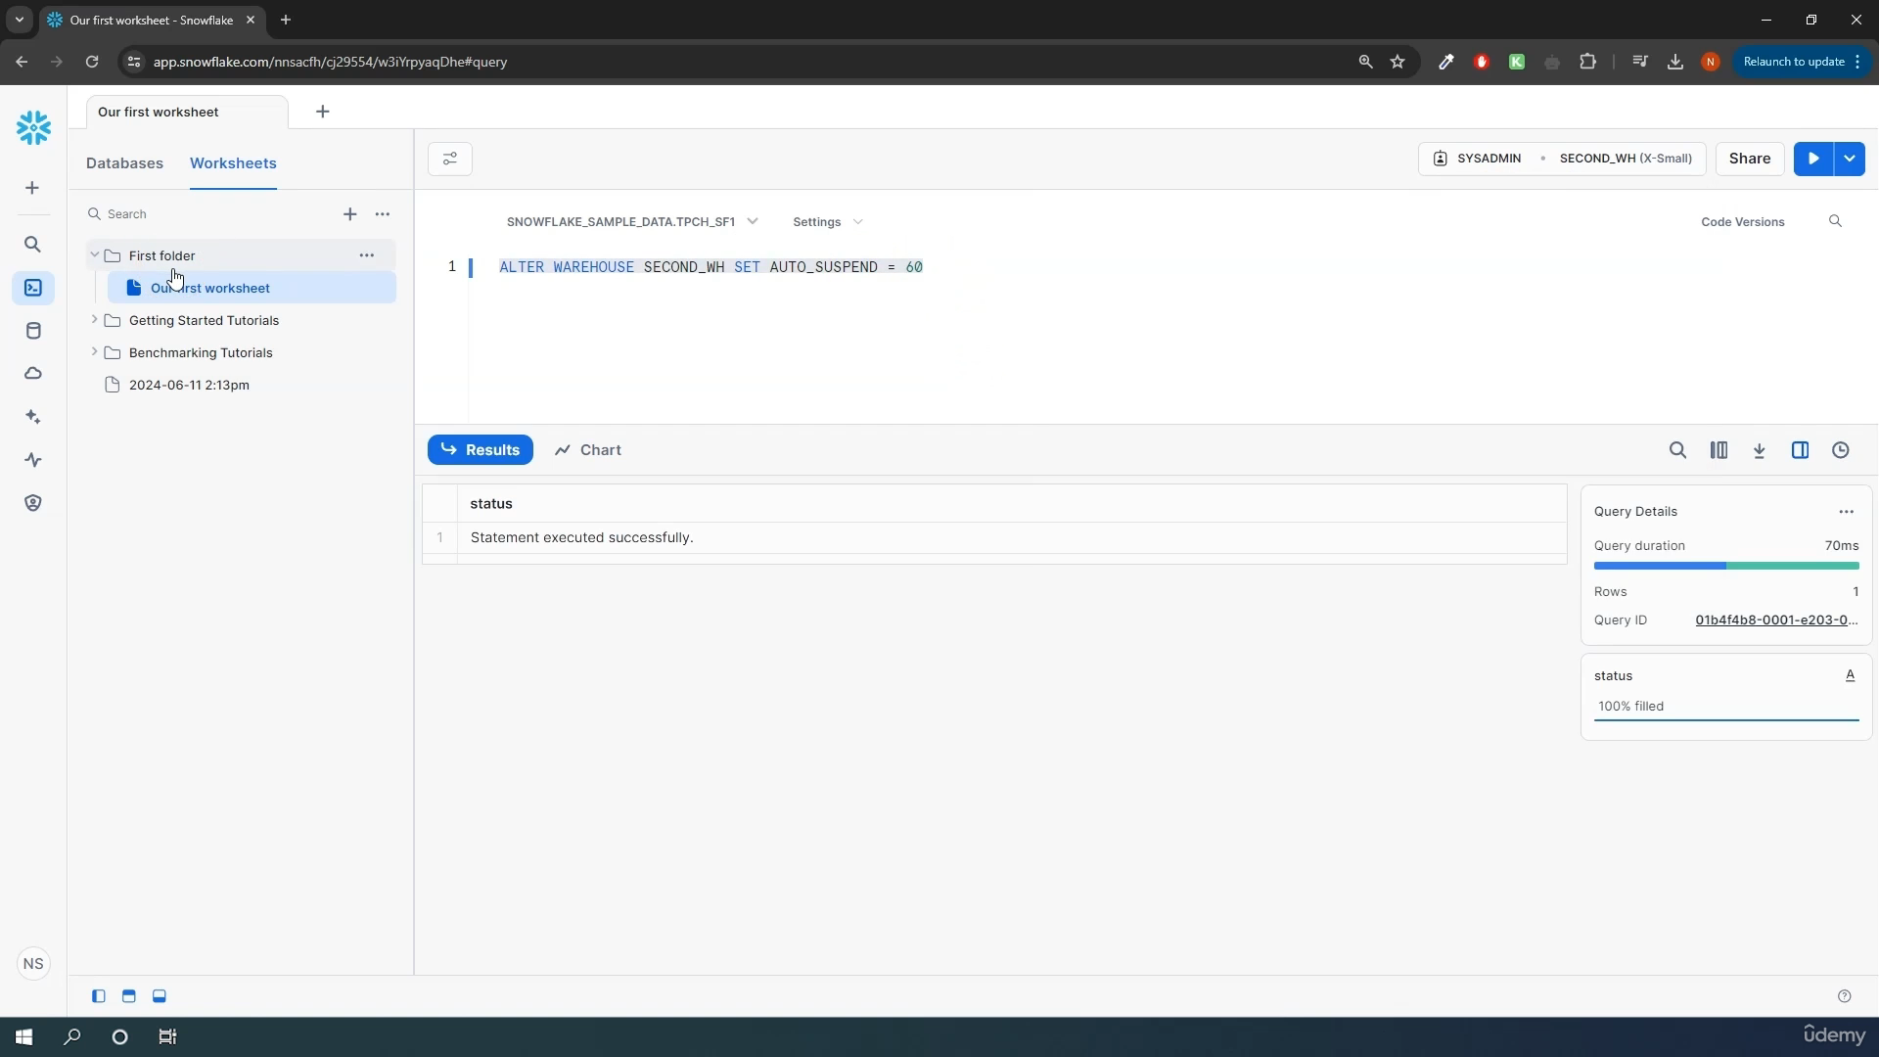

**DROP Wareshouse**

**Drop warehouse second_wh**

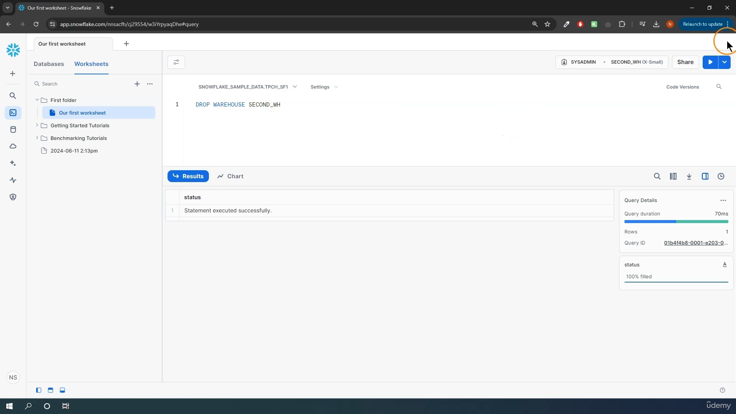

**Scaling Policies**

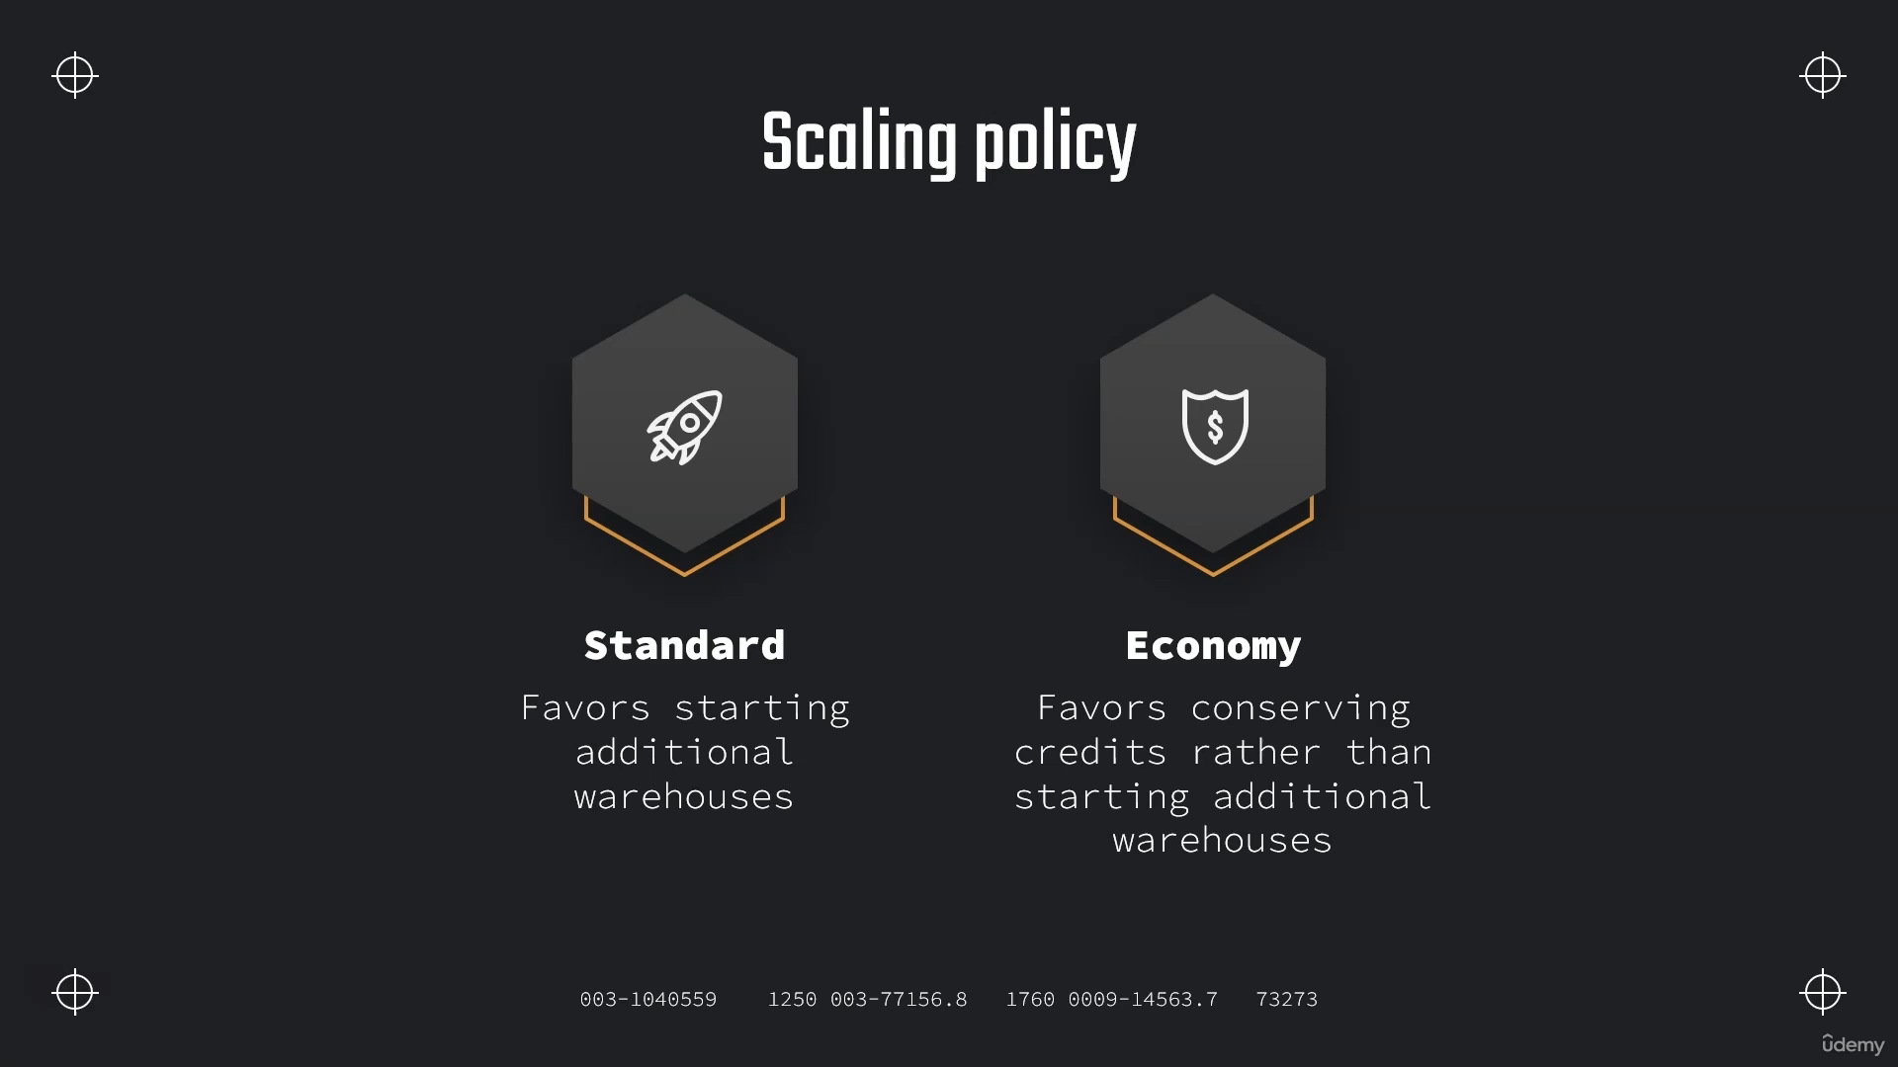

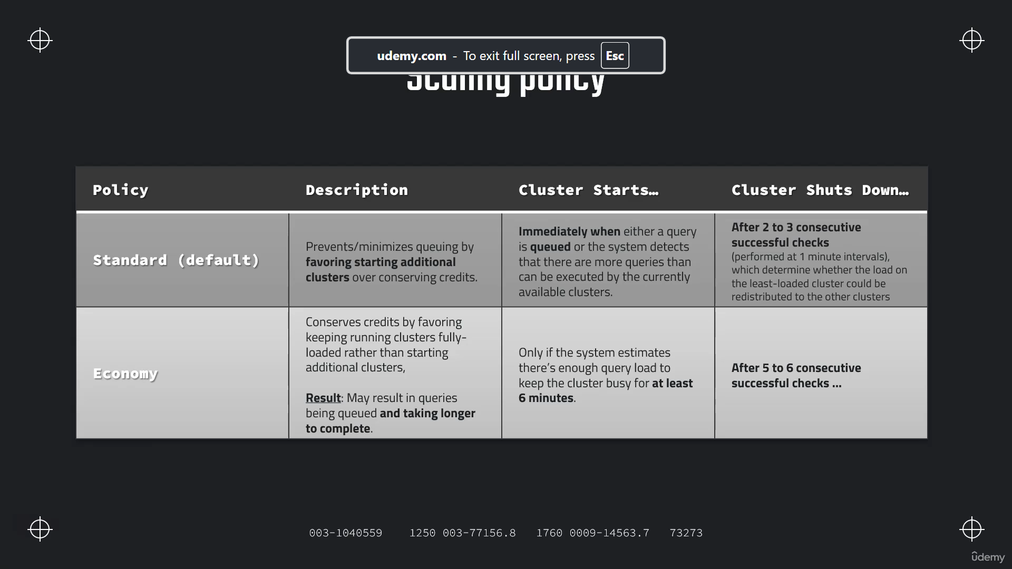

**//Rename data base & creating the table + meta data**

ALTER DATABASE FIRST_DB RENAME TO OUR_FIRST_DB;

CREATE TABLE "OUR_FIRST_DB"."PUBLIC"."LOAN_PAYMENT" (

"Loan_ID" STRING,

"loan_status" STRING,

"Principal" STRING,

"terms" STRING,

"effective_date" STRING,

"due_date" STRING,

"paid_off_time" STRING,

"past_due_days" STRING,

"age" STRING,

"education" STRING,

"Gender" STRING);

**//Check that table is empy**

USE DATABASE OUR_FIRST_DB;

SELECT * FROM LOAN_PAYMENT;

**//Loading the data from S3 bucket**

COPY INTO LOAN_PAYMENT

FROM s3://bucketsnowflakes3/Loan_payments_data.csv

file_format = (type = csv

field_delimiter = ','

skip_header=1);

**//Validate**

SELECT * FROM LOAN_PAYMENT;

**What is Data warehouse ?**

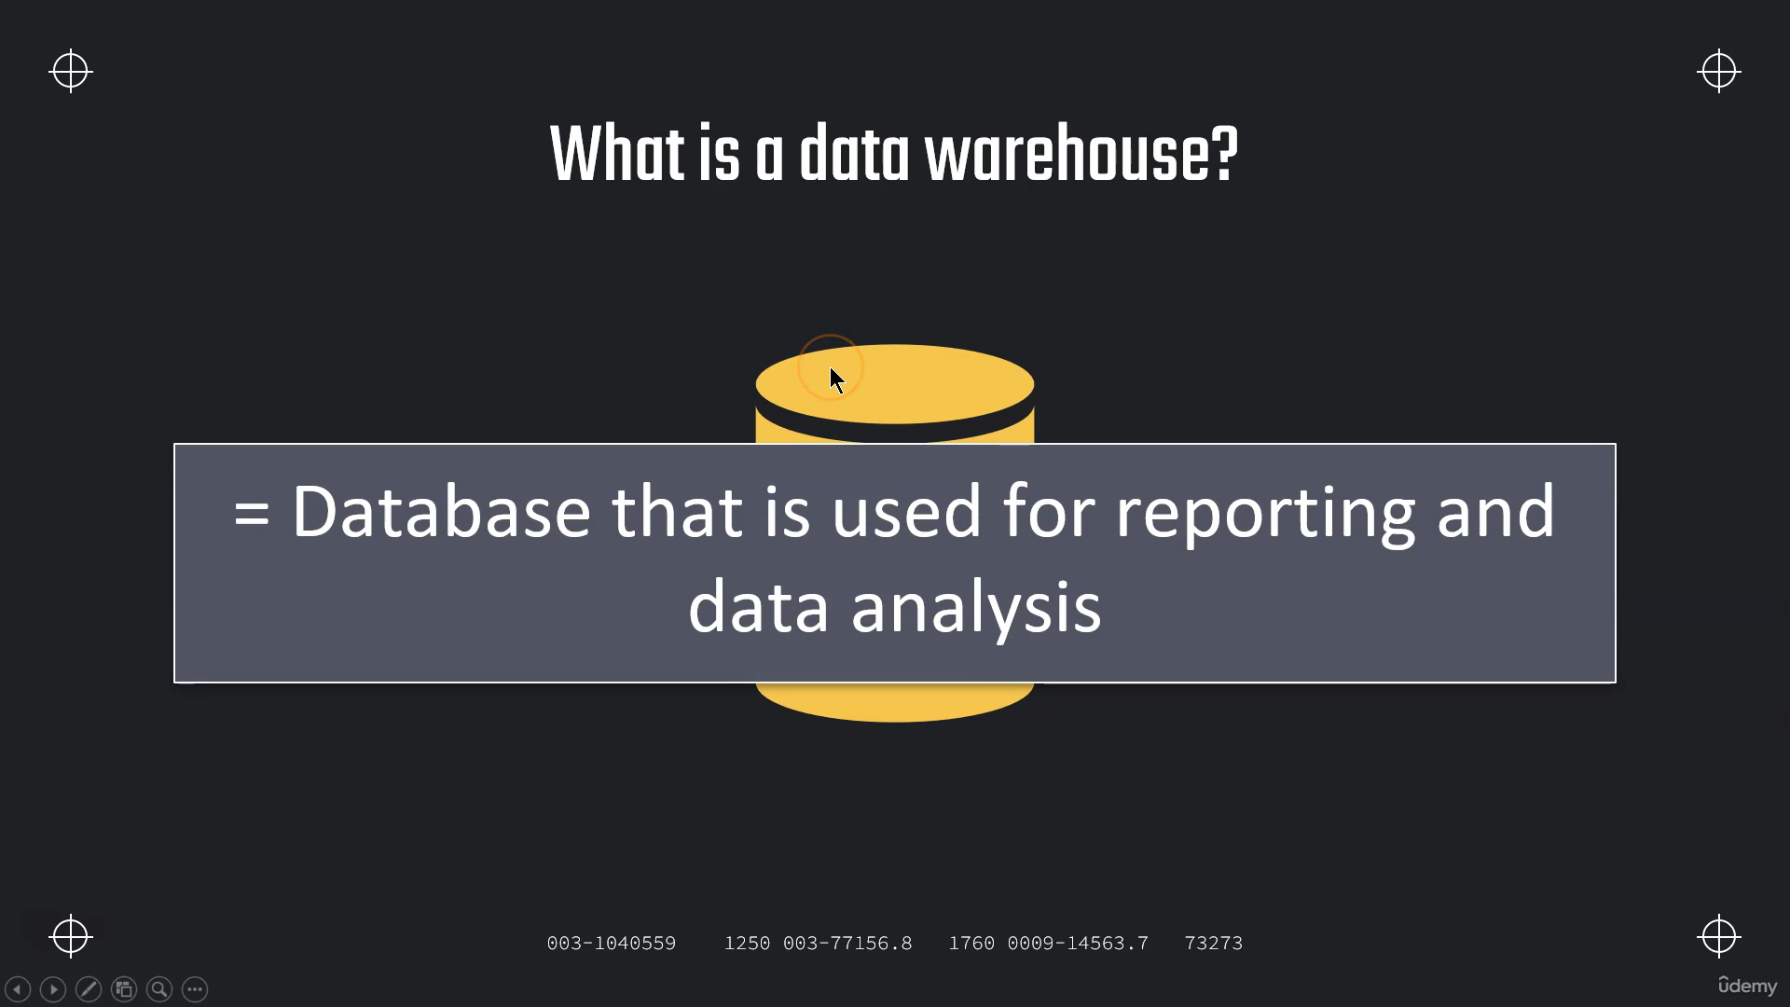

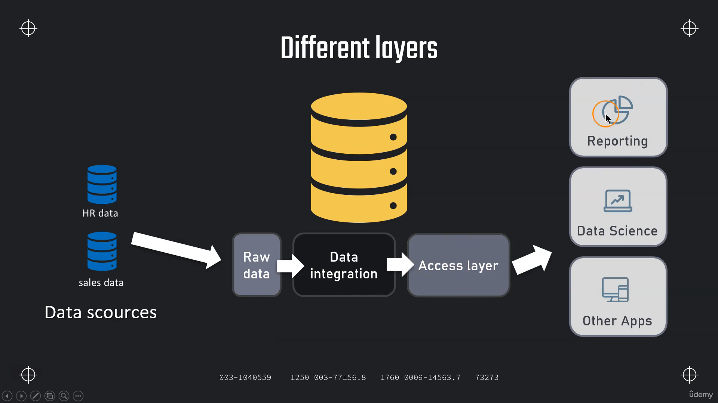

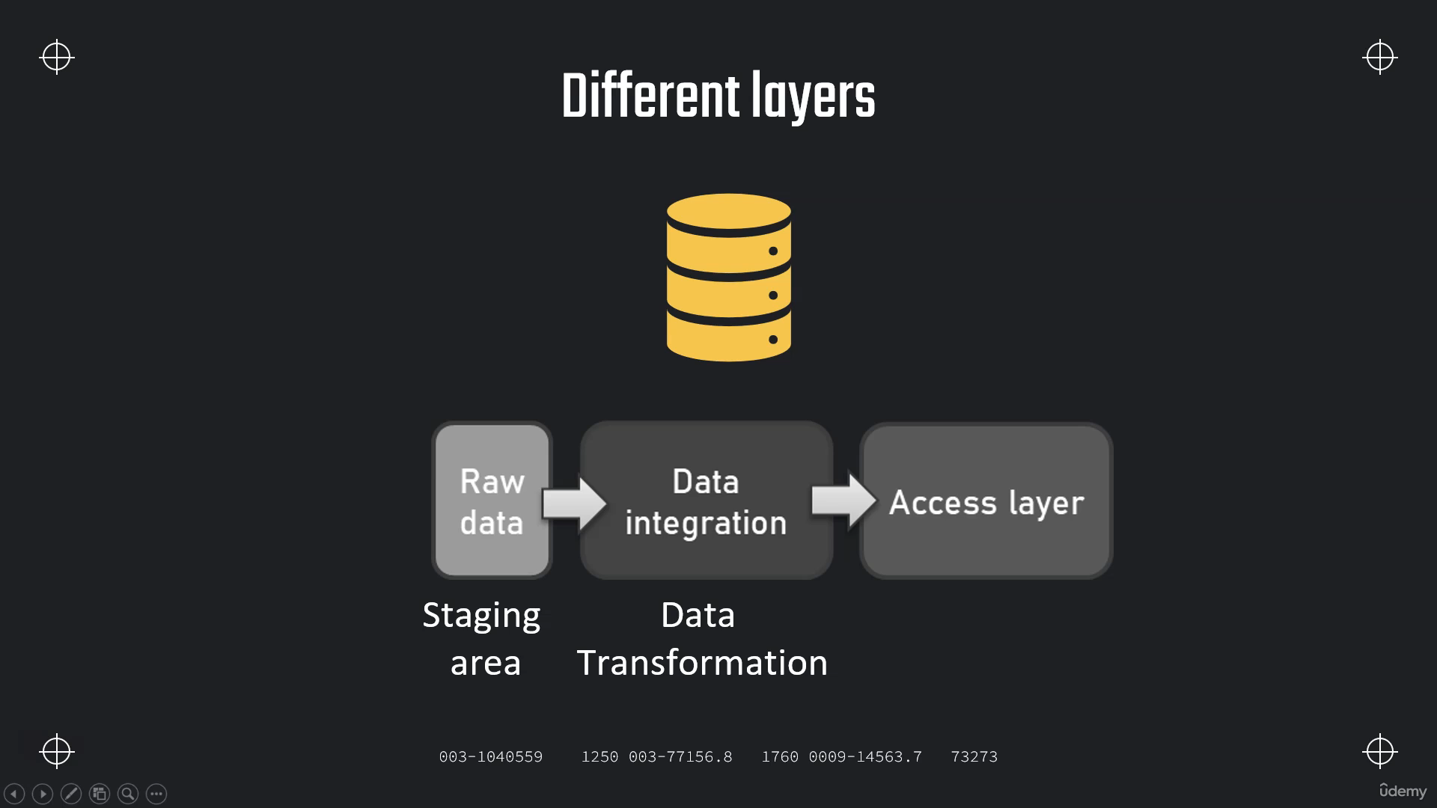

**Cloud Computing**

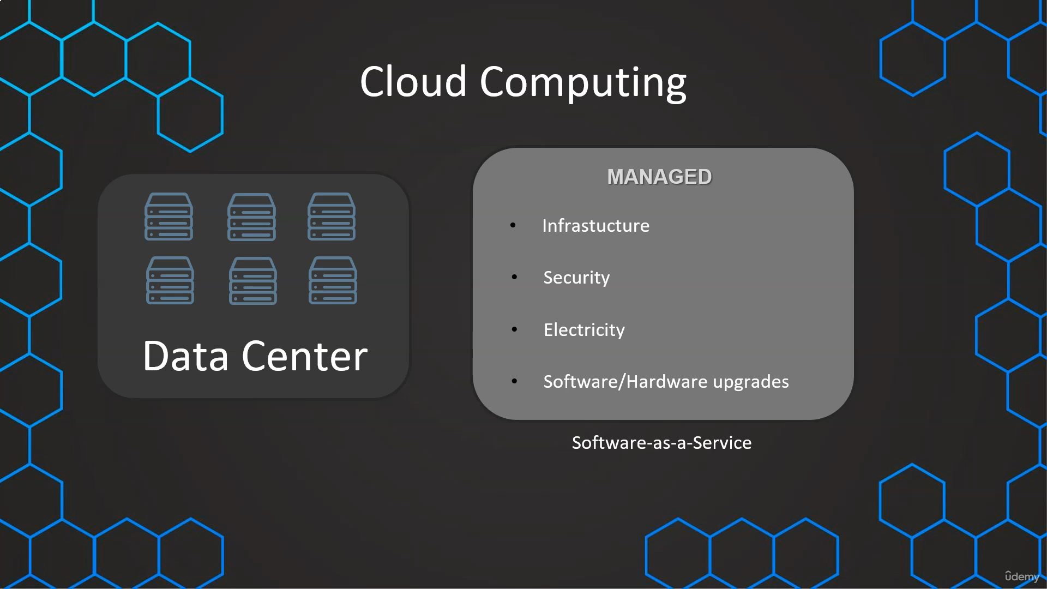

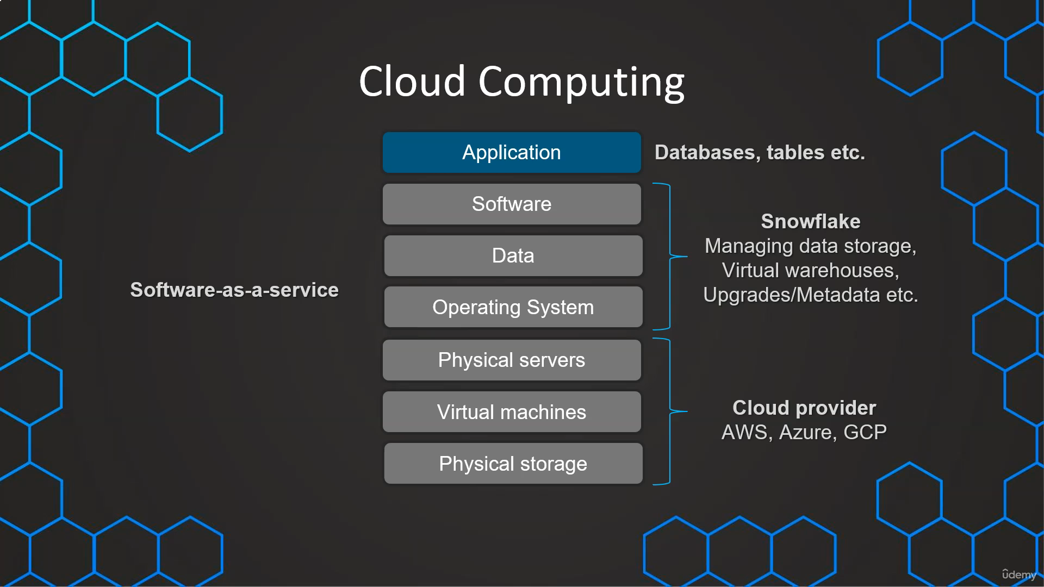

**Snowflake Editions**

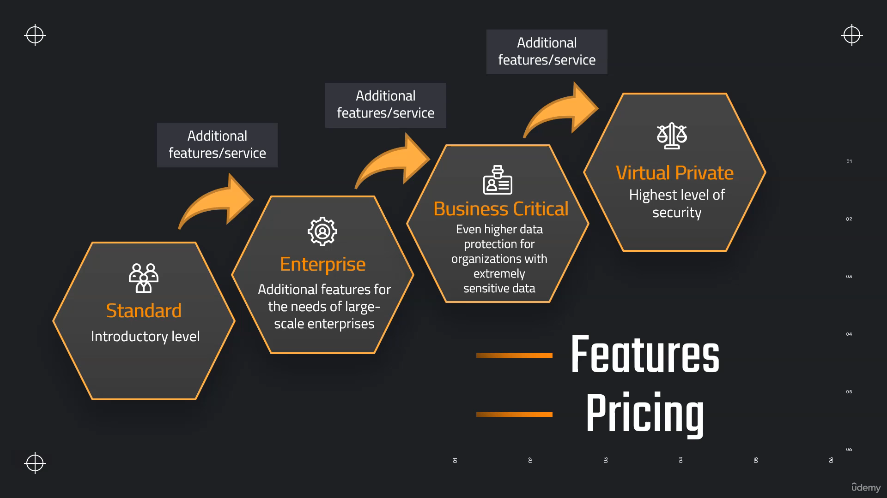

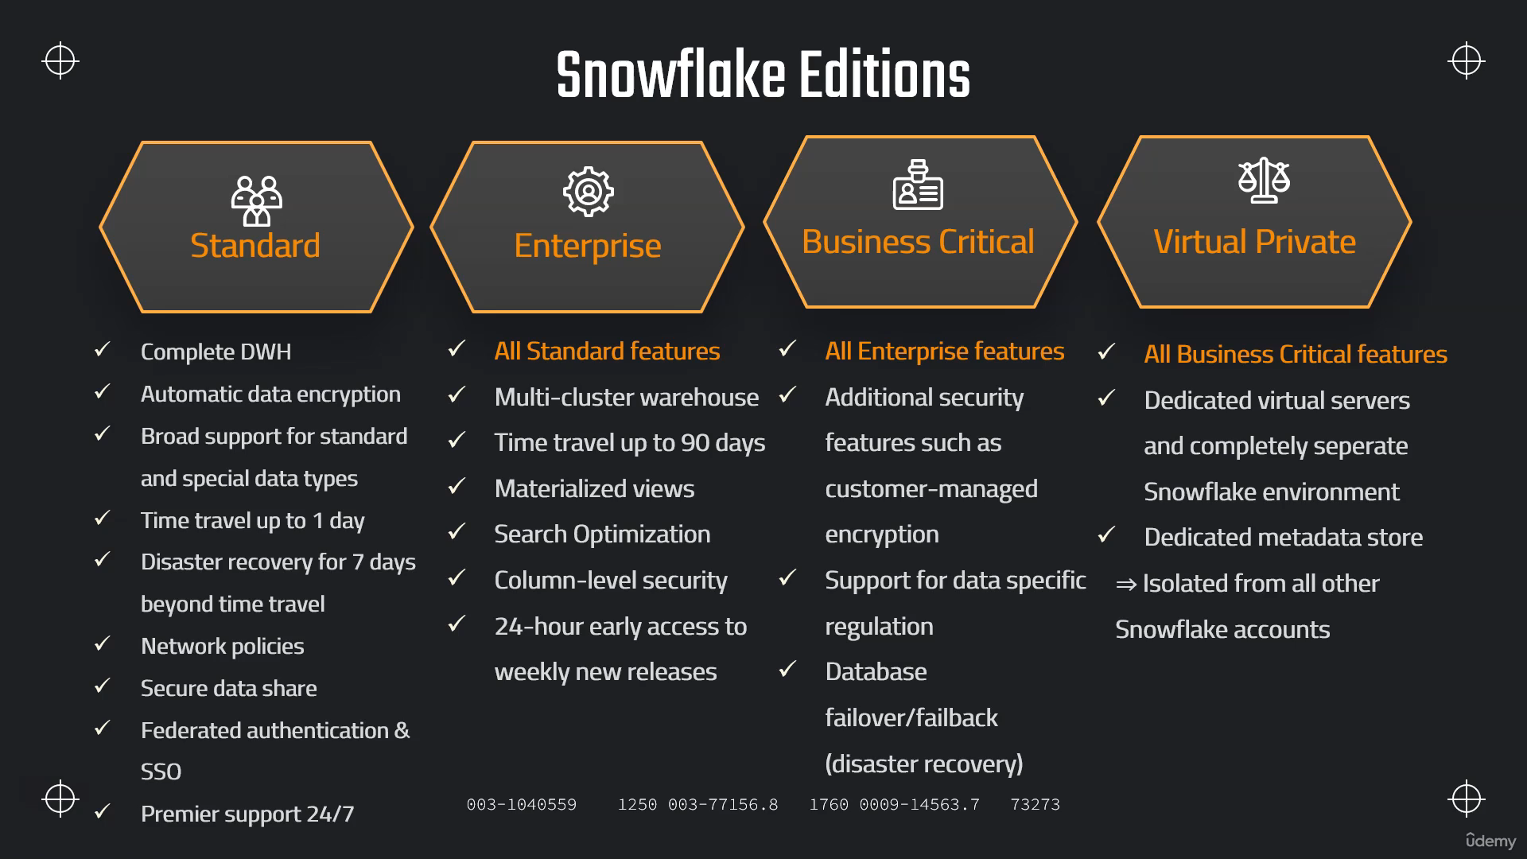

**Snowflake Pricing**

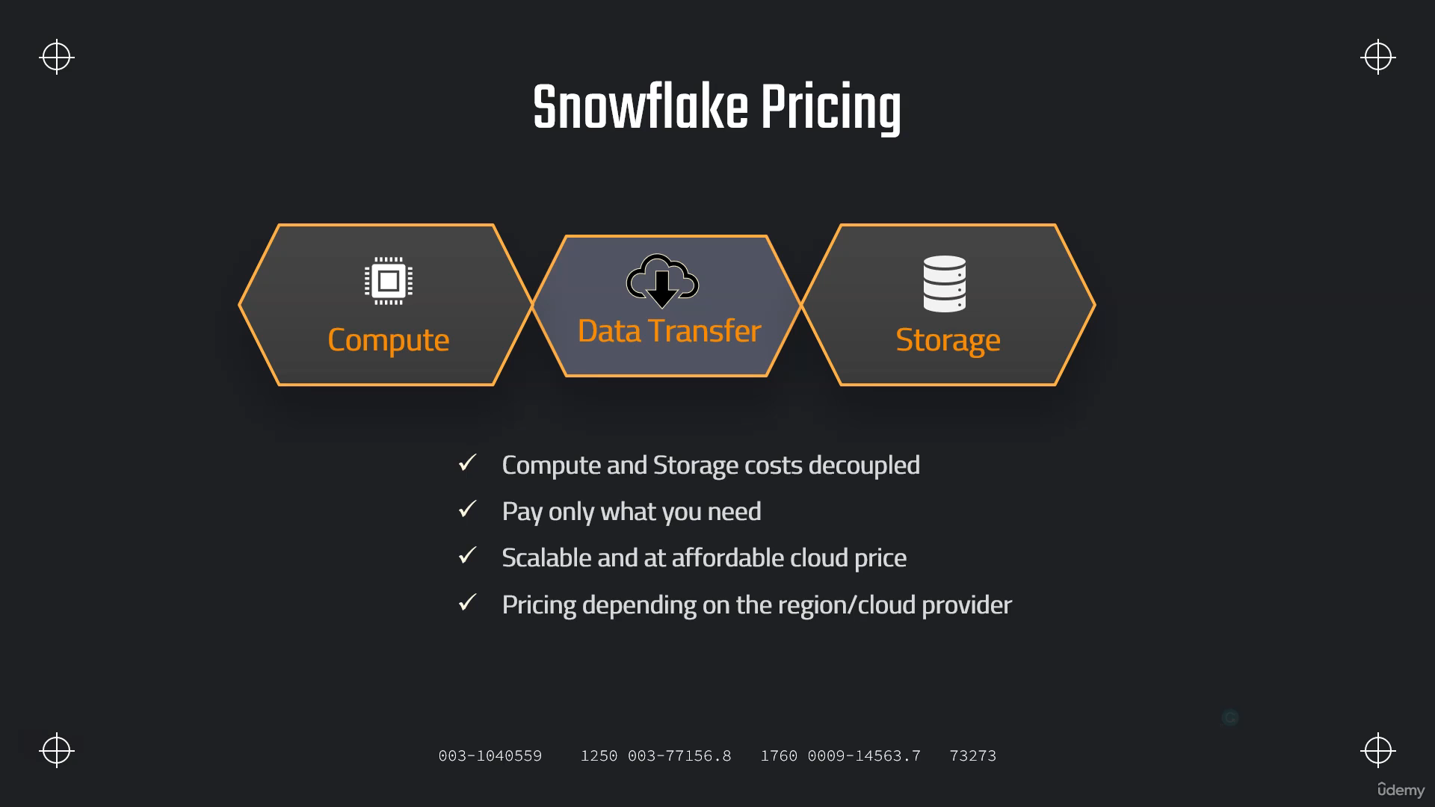

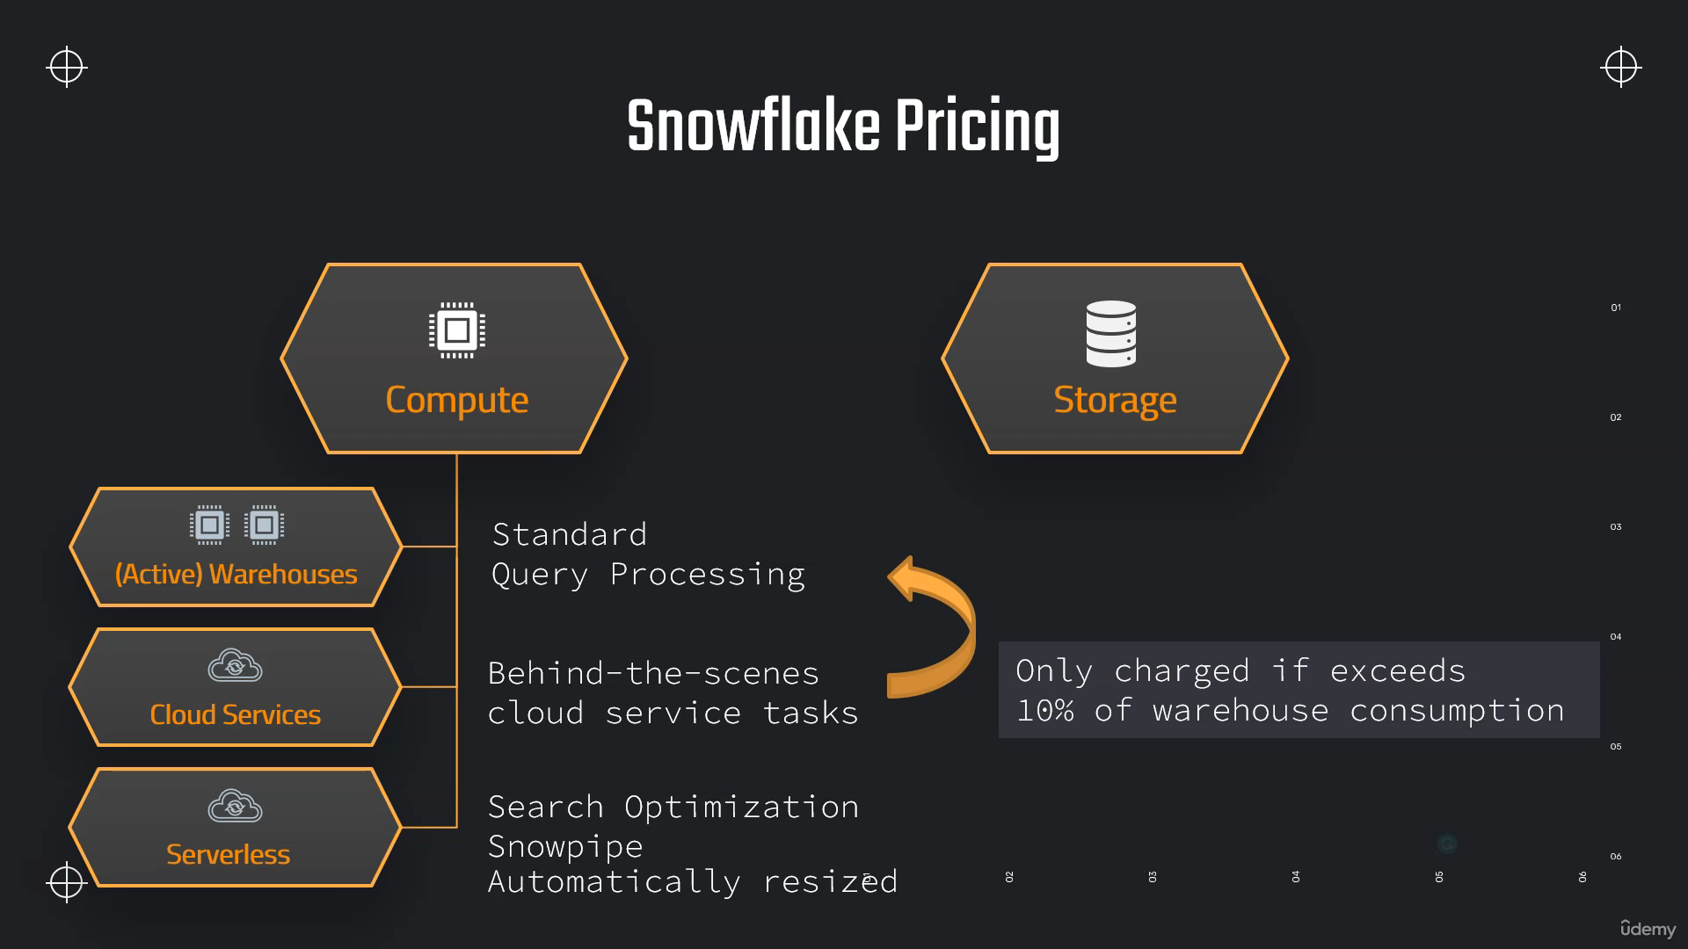

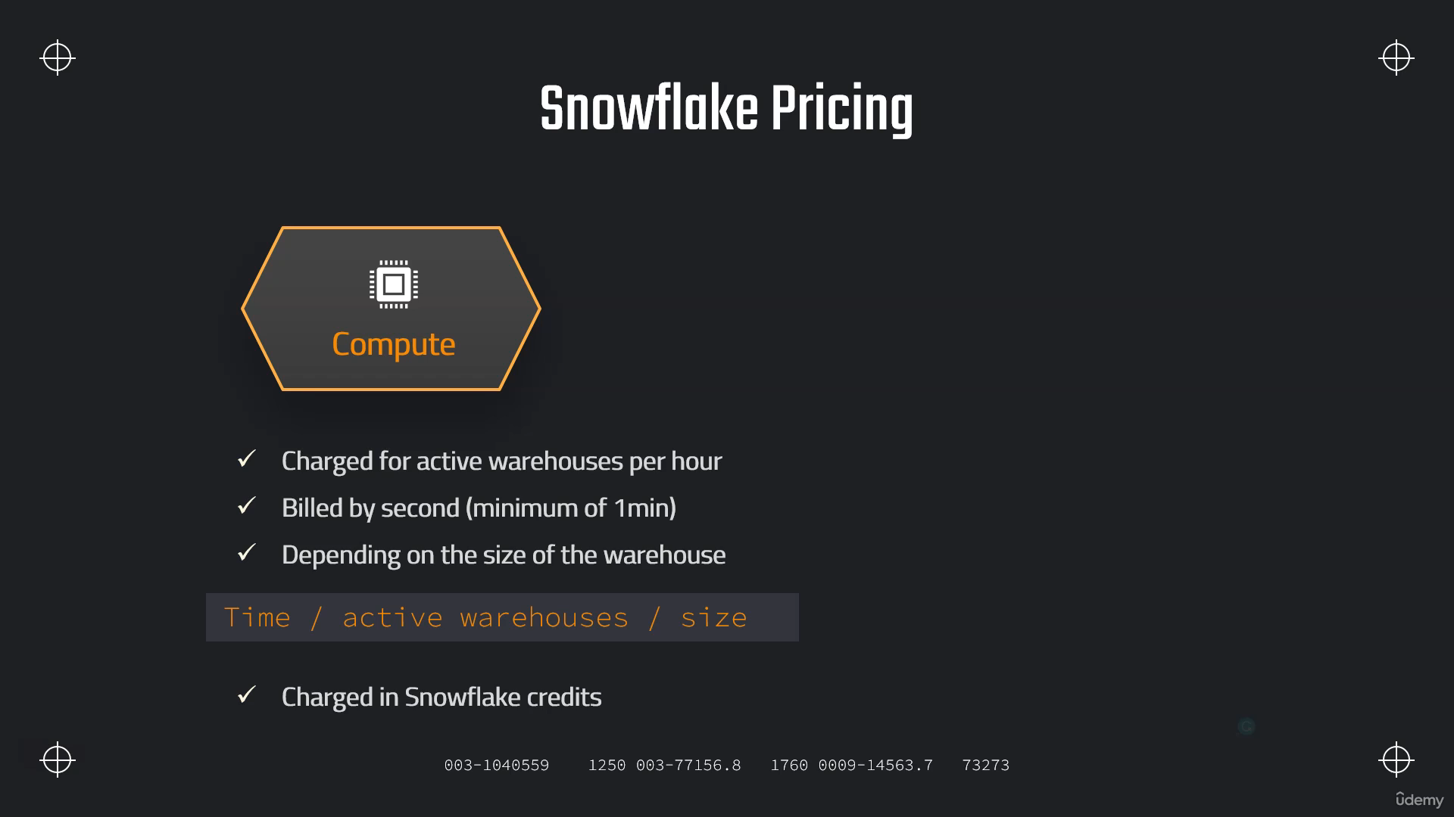

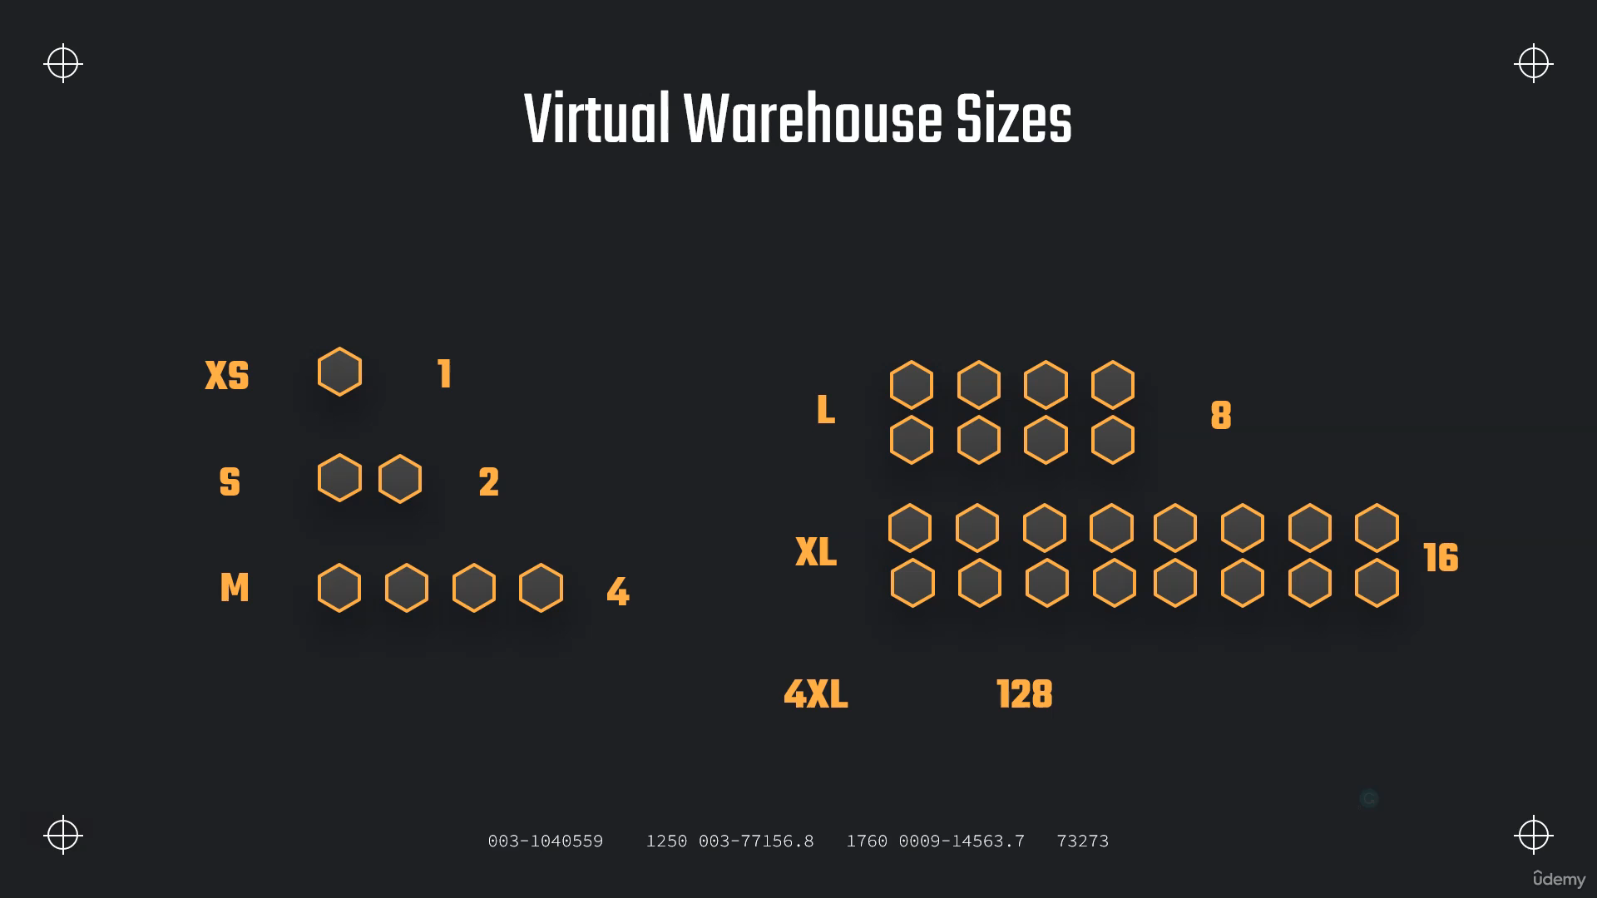

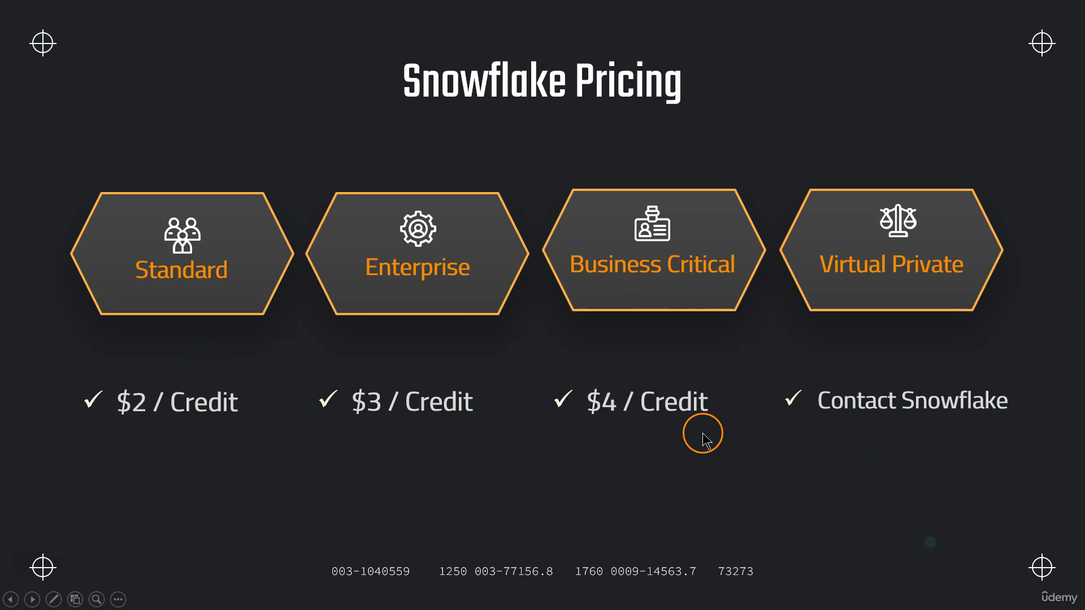

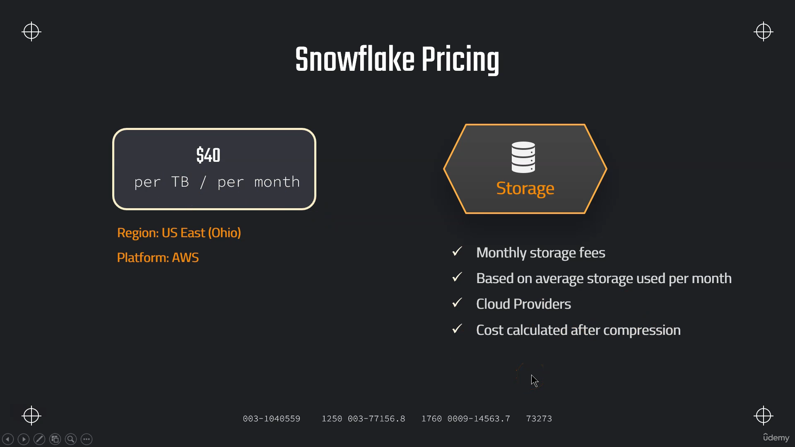

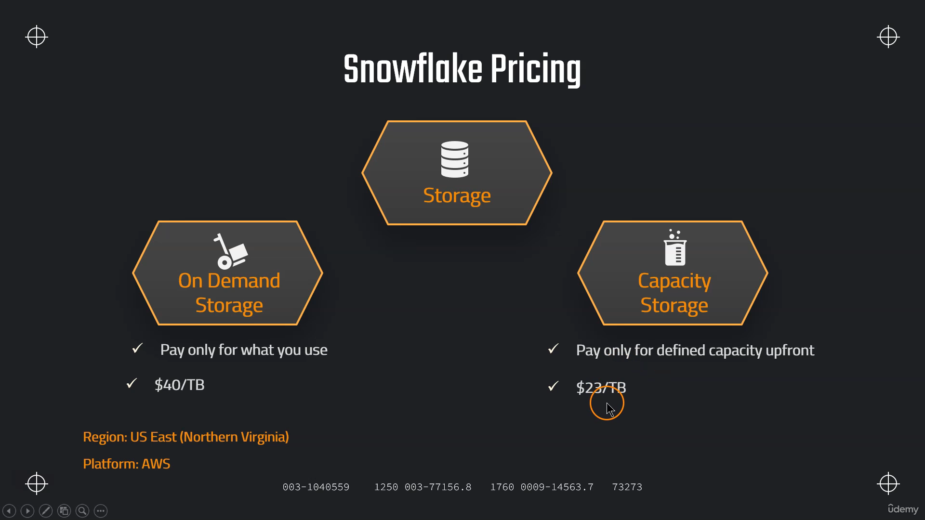

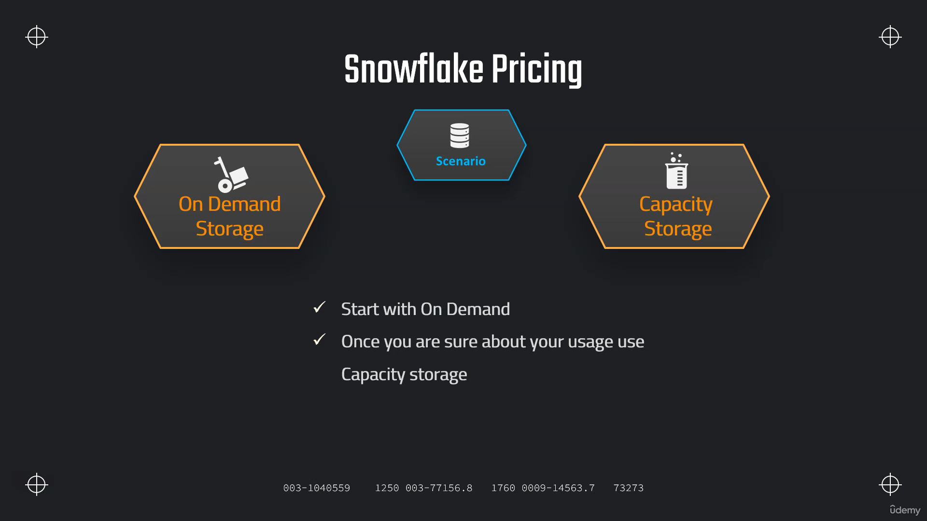

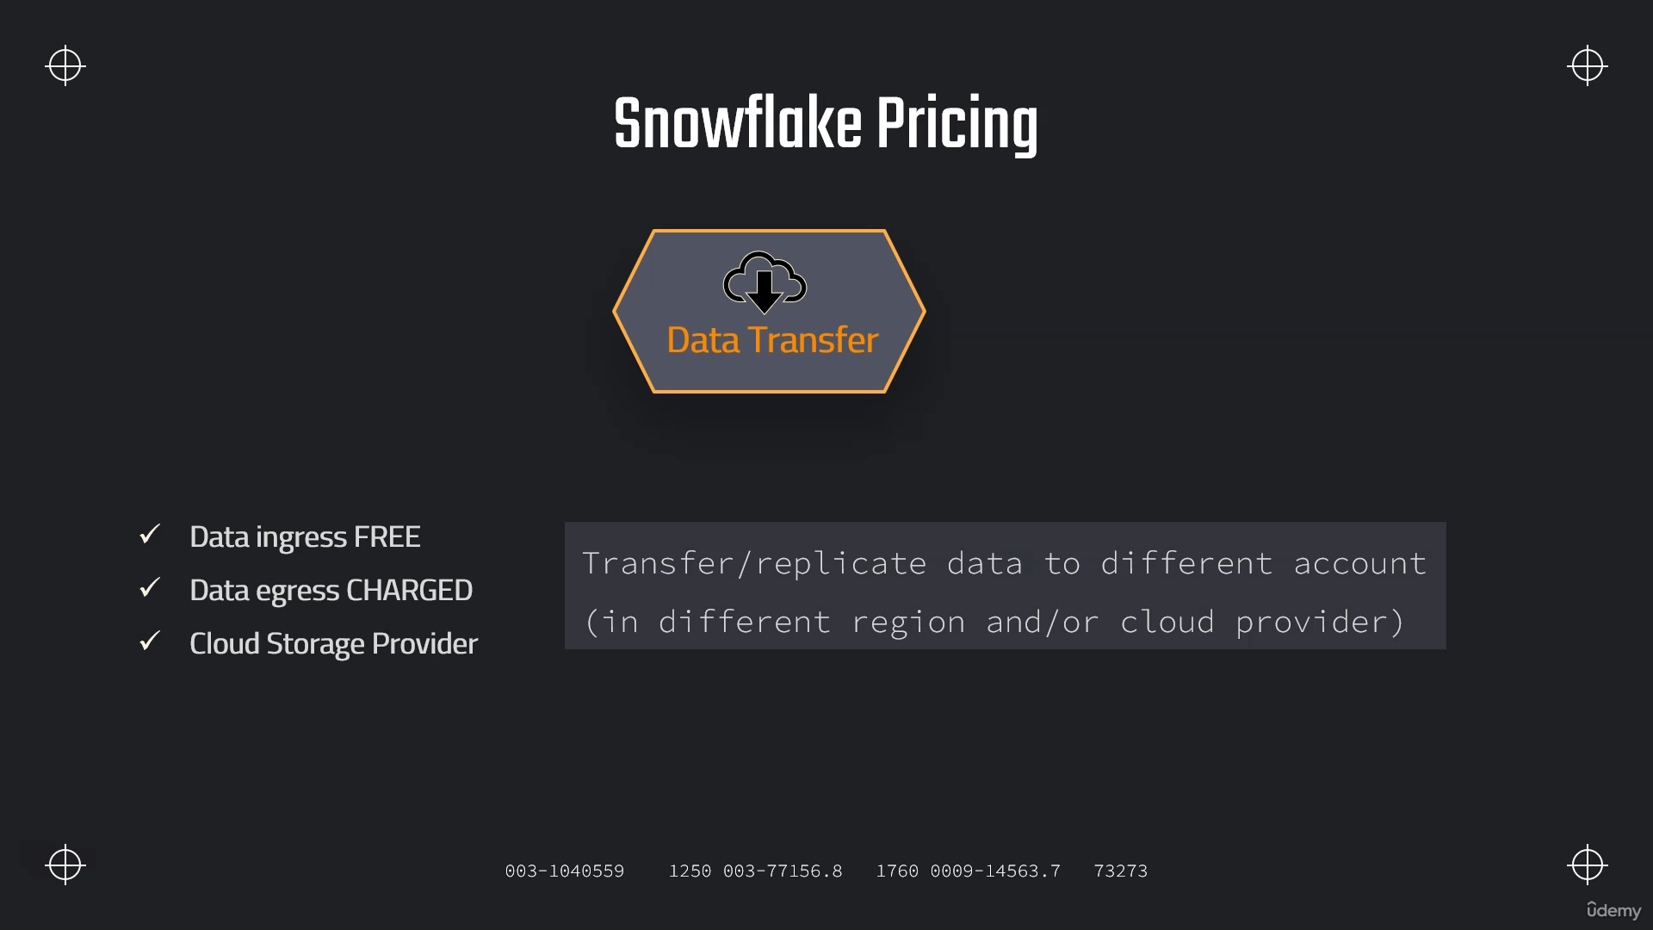

**How to Monitor Snowflake Usage**

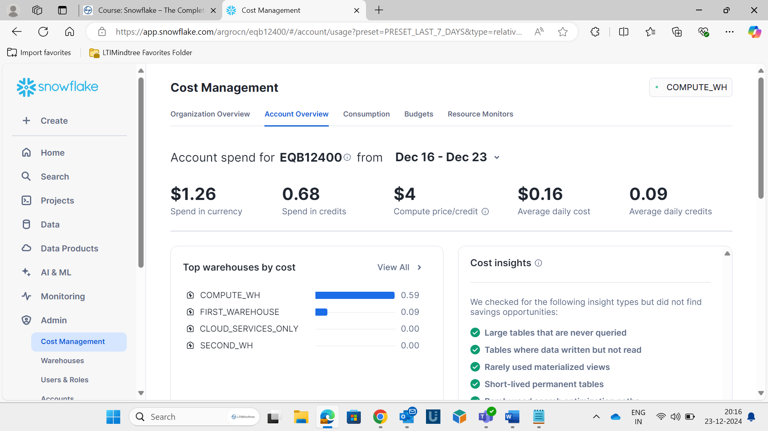

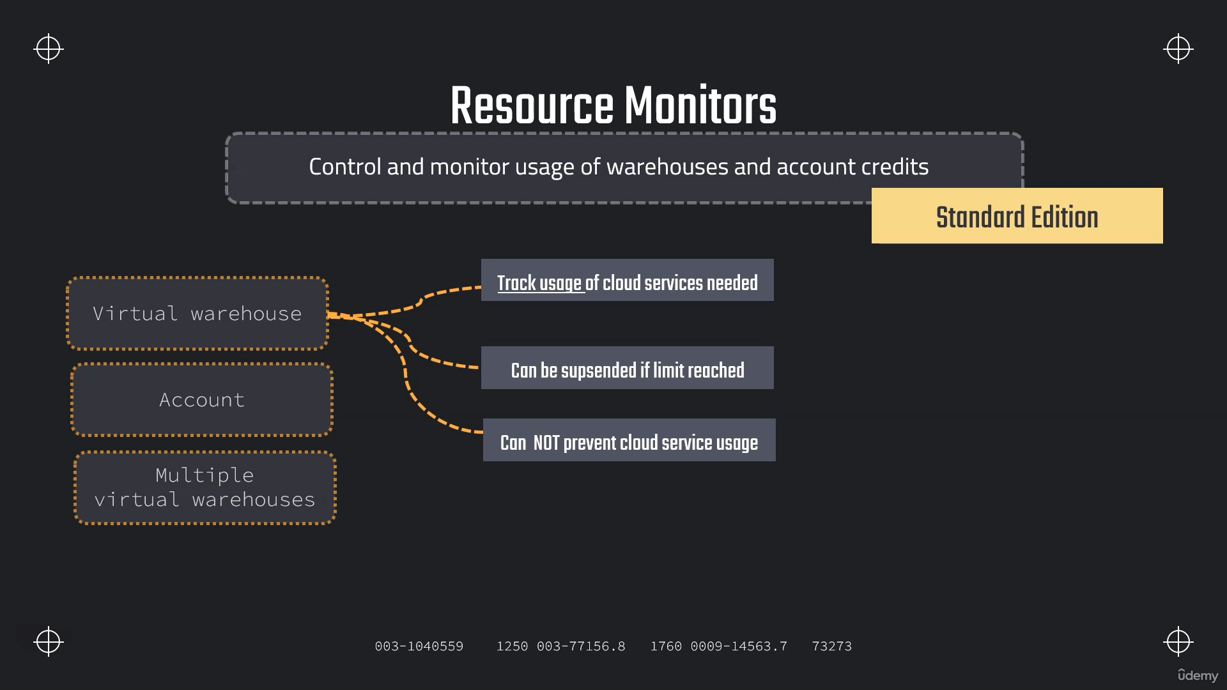

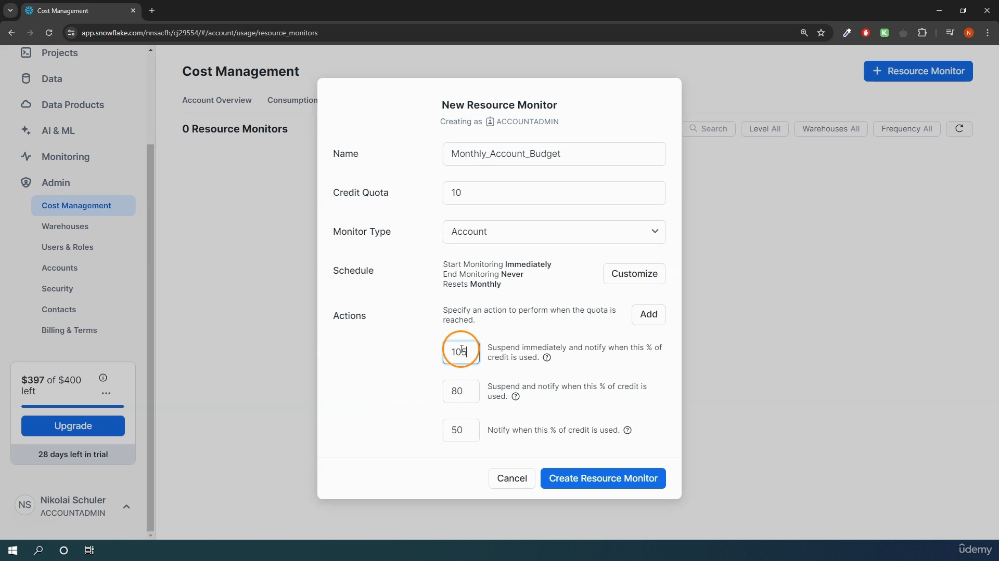

**Roles In Snowflake**

